**CHANDIGARH UNIVERSITY**

**UNIVERSITY INSTITUTE OF ENGINEERING**

**DEPARTMENT OF COMPUTER SCIENCE AND ENGINEERING**



|  |  |
| --- | --- |
| **Submitted by:** Yash Gupta (20BCS5009) | **Submitted To:** Er. Daulat Ram (13701) |
| **Subject Name:** | Project Based Learning in Java |
| **Subject Code:** | 20CSP-321 |
| **Branch:** | CSE |
| **Semester:** | 5th |

LAB INDEX

|  |  |  |  |  |  |  |  |
| --- | --- | --- | --- | --- | --- | --- | --- |
| Sr.  No | Program | Date |  | Evaluation | | | Sign |
| LW  (12) | VV  (8) | FW  (10) | Total (30) |
| 1. |  |  |  |  |  |  |  |
| 2. |  |  |  |  |  |  |  |
| 3. |  |  |  |  |  |  |  |
| 4. |  |  |  |  |  |  |  |
| 5. |  |  |  |  |  |  |  |

# 

# Experiment-2.3

Aim :-

Write a Program to perform the basic operations like insert, delete, display and search in list. List contains

String object items where these operations are to be performed.

Code and Output :-

package file;  
import java.util.ArrayList;  
import java.util.Scanner;  
  
class arraylist{  
 static ArrayList<String> *list*= new ArrayList<>();  
  
 private static void print1(){  
 System.*out*.println("1. Insert\n" +  
 "2. Search\n" +  
 "3. Delete\n" +  
 "4. Display\n" +  
 "5. Exit");  
 System.*out*.println("Enter your choice");  
 }  
 private static void print(int n ){  
  
 Scanner s= new Scanner(System.*in*);  
 switch (n) {  
 case 1:  
 System.*out*.println("Enter the item to be inserted");  
 String insert = s.nextLine();  
 *list*.add(insert);  
 *print1*();  
 n=s.nextInt();  
 *print*(n);  
 break;  
 case 2:  
 System.*out*.println("Enter the item to be searched");  
 String search = s.nextLine();  
 if (*list*.contains(search)) {  
 System.*out*.println("Item found in the list.");  
 } else {  
 System.*out*.println("Item not found in the list.");  
 }  
 *print1*();  
 n=s.nextInt();  
 *print*(n);  
 case 3:  
 System.*out*.println("Enter the item to be deleted");  
 String delete = s.nextLine();  
 if (*list*.contains(delete)) {  
 *list*.remove(delete);  
 System.*out*.println("deleted");  
 } else {  
 System.*out*.println("Item not present in the list");  
 }  
 *print1*();  
 n=s.nextInt();  
 *print*(n);  
  
 case 4:  
 System.*out*.println("The items in the list are :");  
 for (String value : *list*) {  
 System.*out*.println(value);  
 }  
 *print1*();  
 n=s.nextInt();  
 *print*(n);  
  
 case 5:  
 System.*exit*(0);  
 break;  
 default:  
 System.*out*.println("Enter a valid number");  
 n=s.nextInt();  
 *print*(n);  
 }  
 }  
  
 public static void main(String[] args) {  
 Scanner s= new Scanner(System.*in*);  
 *print1*();  
 int n =s.nextInt();  
 *print*(n);  
 }  
}

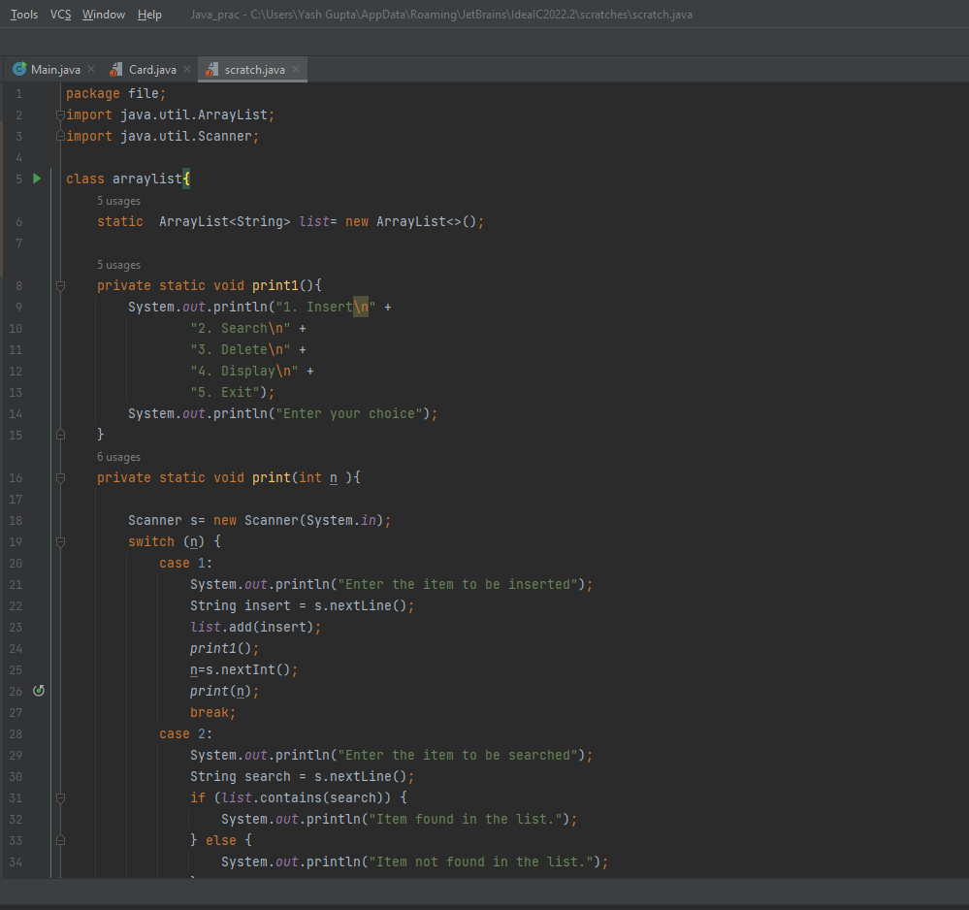

Output **:-**

1. Insert

2. Search

3. Delete

4. Display

5. Exit

Enter your choice

1

Enter the item to be inserted

Bottel

1. Insert

2. Search

3. Delete

4. Display

5. Exit

Enter your choice

1

Enter the item to be inserted

Water

1. Insert

2. Search

3. Delete

4. Display

5. Exit

Enter your choice

1

Enter the item to be inserted

Cap

1. Insert

2. Search

3. Delete

4. Display

5. Exit

Enter your choice

1

Enter the item to be inserted

Monitor

1. Insert

2. Search

3. Delete

4. Display

5. Exit

Enter your choice

2

Enter the item to be searched

Mouse

Item not found in the list.

1. Insert

2. Search

3. Delete

4. Display

5. Exit

Enter your choice

2

Enter the item to be searched

Monitor

Item found in the list.

1. Insert

2. Search

3. Delete

4. Display

5. Exit

Enter your choice

4

The items in the list are :

Bottel

Water

Cap

Monitor

1. Insert

2. Search

3. Delete

4. Display

5. Exit

Enter your choice

3

Enter the item to be deleted

Cap

deleted

1. Insert

2. Search

3. Delete

4. Display

5. Exit

Enter your choice

4

The items in the list are :

Bottel

Water

Monitor

1. Insert

2. Search

3. Delete

4. Display

5. Exit

Enter your choice

5

